SHIP TO:  Iowa State University  Central Receiving Facility  2105 East Lincoln Way  Ames, Iowa 50010 | 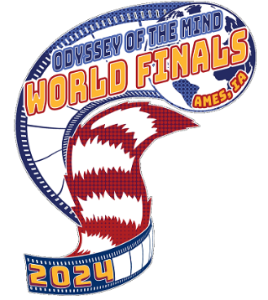
Attention: Corey Bickelhaupt  Phone: (515) 294-1804 | CARTON _____ OF _____

Membership Name (School): ________________________________________________________

Membership Number: ______________________________________________________________

Address: ______________________________________________________________

City_______________________________________State_______________

Contact Phone Number: _____________________ Email ___________________________________
PROBLEM 1 : Drive In Movie
PROBLEM 2 : AI Tech-NO-Art
PROBLEM 3 : Opening Night Antics
PROBLEM 4 : Deep Space Structure
PROBLEM 5 : Rocking World Detour

DIVISON I
DIVISON II
DIVISON III
DIVISON IV

***Please make duplicate copies of this label and attach to all items being shipped***

REMEMBER: Include only items for one Problem & Division in each container!

THIS CONTAINER MUST BE ABLE TO FIT THROUGH A STANDARD DOORWAY, 32”x72”

